Name___________________________________

Quick Quiz

**Unit Rate 4**

Identify the unit rate:

1. 8 chocolate bars cost $13 2.

**$_________ per bar unit rate =_________**

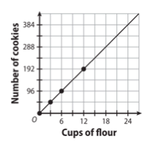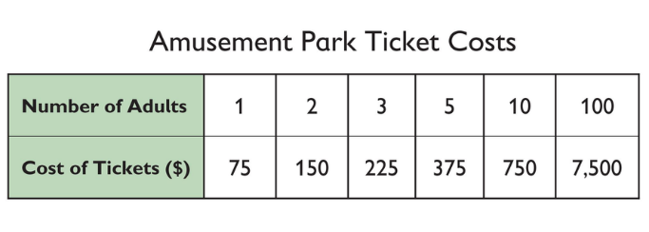

3. 4.

**________**

**cookies per cup of flour**

**$_________ per ticket**

____________________________________________________________________________

Corrections

**Unit Rate 4**

Identify the unit rate:

1. 8 chocolate bars cost $13 2.

**$_________ per bar unit rate =_________**



3. 4.

**________**

**cookies per cup of flour**

**$_________ per ticket**